CHRIST (Deemed to be University)
School of Sciences
Department of Statistics and Data Science

MSc Data Science
Academic Year: 2024–2026

Course Code: MDS481
Course Name: Project I

CIA II
(System Design Document)

Project Title
Smart Resume Analyzer and Job Recommendation Web Application using Django

Submitted by: Aadrita Pal
Register Number: 24122001

Guide Name: Alwin Joseph

System Architecture Design
Frontend (HTML, Bootstrap UI) → Django views (Backend)→ ML Logic (Resume Analyzer) → Output

Data Flow Diagram
User → Upload Resume → Resume Processing (ML Model) → Skill Extraction and Processing

Module Design
1. Authentication Module
- Login/Logout functionality
2. Resume Upload Module
- Handles file upload
3. Processing Module
- Extract text
- Match skills
4. Analysis Module
- Score calculation
- Job mapping
5. Visualization Module
- Chart generation
6. UI Module
- Dashboard display

Interface Design
- Login Page
- Upload Page
- Result Dashboard

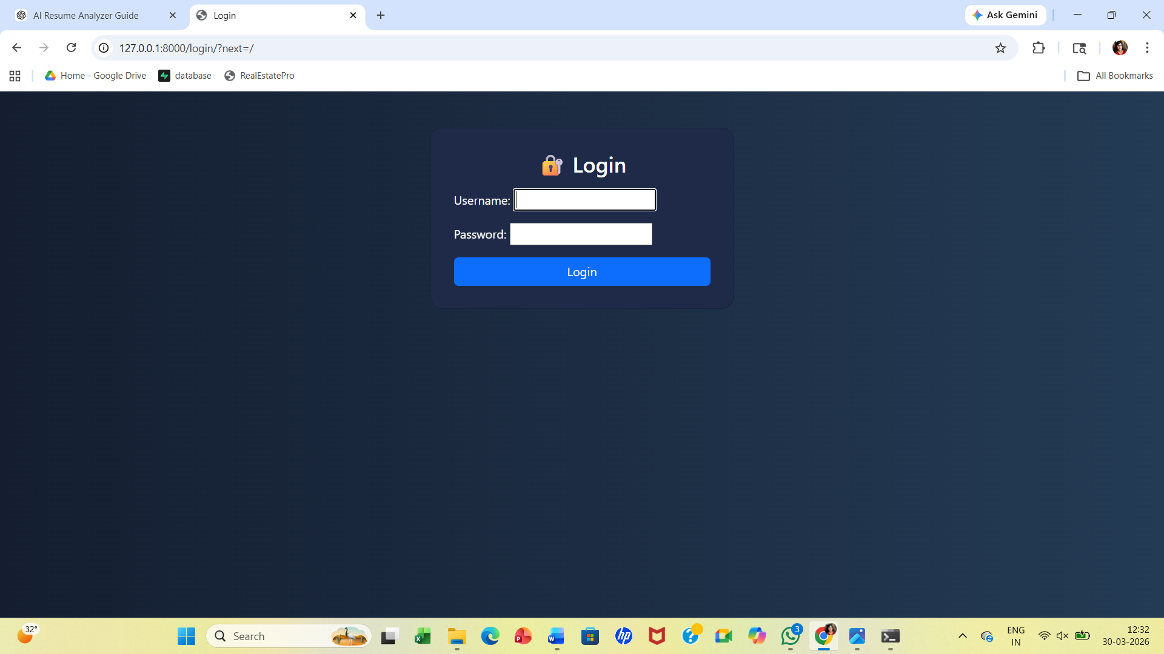
Login Page


Upload Page

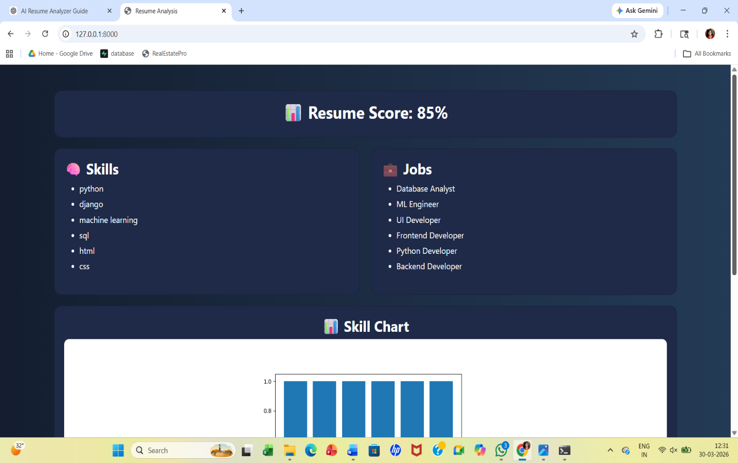
Result Dashboard Page
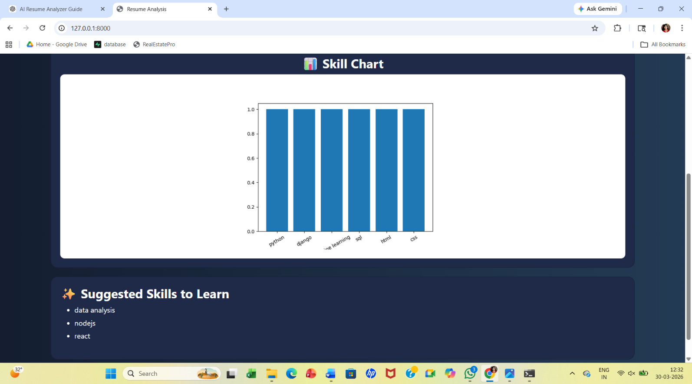
Result Dashboard Page

References:
- https://ijsprem.com
- https://www.theseus.fi
- https://www.geeksforgeeks.org

